*Technical Specification:*

MPU6050 Module: The module MPU6050 is a 3-axis accelerometer with 3-axis gyroscope. The module supports 16-bit resolution for both acceleration and gyro sensing. Moreover, the module supports SPI (Serial Peripheral Interface) and I2C (Inter Integrated Circuit) which are most used real data communication methods in microcontrollers. The accelerometer range is up to 16g, and gyro sensing is 2000°. Pitch, roll and yaw, which are the output of the gyroscope define the orientation of the chip. This feature is effective to measure the orientation of an object adjusted to a mechanical body. Furthermore, the accelerometer output and time can be potentially used to define the translation movement of the same body mechanically adjusted. However, the module is costlier than many alternatives.

#### Table 2.5: Specifications of MPU6050

|  |  |
| --- | --- |
| Category | Details |
| A/D Converter resolution | 16 bits |
| Operating Voltage | 3-5 V |
| Communication protocol | I2C |
| Gyro range | ±250, 500, 1000, 2000  °/s |
| Accelerometer range | ±2, 4, 8, 16 g |

Figure 2.24: MPU6050 gyro sensor

Digital Hall effect sensor: A digital hall effect sensor will output in binary. Thus, the sensor will provide a signal High for the threshold magnetic flux reached by the sensor. The output will remain High as long as the provided flux is higher than the required threshold magnetic flux. Some common models are 6851, A3144 and widely available in our region. The sensor can be potentially used as a switch or input mechanical signal into electrical.

Figure 2.19: A3144 Digital Hall effect sensor

Analog Hall effect sensor: An analog hall effect sensor will output an analog voltage level proportional to the magnetic flux density. Also, the voltage level is dependent on the model of the hall sensor model. A very common model for the linear Hall effect sensor is 49E, which will output 2mV/Gauss as a voltage output. Therefore, the hall effect sensor is very much beneficial in the sense of proximity sensing of a magnet adjacent to the hall sensor. In other words, the analog hall sensor outputs much more precise electric signal in accordance with mechanical signal.

Figure 2.20: SS49E linear hall effect sensor.

Reed Switch: A very cheap alternative to the hall sensors are reed switches. Reed switch is used to electrically sense the presence of magnetic field. However, the mechanical process is much slower and digital output limits the sensing capability. Also, the polarity of the magnetic field is not also possible to determine from the output.

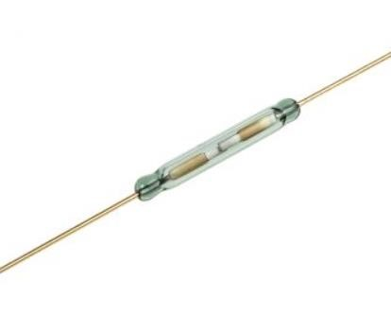

Figure 2.21: Reed sensor

Resistive rotary sensor: A potentiometer can output mechanical rotation in electrical by using the voltage divider rule. The output is pretty stable and accurate. However, the process involves static friction which suggest long time wearing of the contact points. So, this alternative is not a first choice unless talking about cost. Because potentiometers are accountably cheaper than most other alternatives.

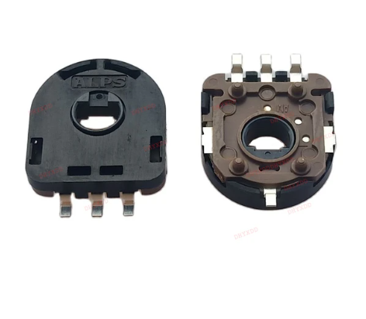

Figure: Resistive rotary sensor

AS5600 Hall effect potentiometer: The hall effect angle sensor is made of indium antimonide. This hall sensor is used so that we can indicate the proper angle of the magnetic field lines which go through this sensor. By using this we can see the reading of the magnetic flux vector which will change from time to time based on movement. Indium antimonide is placed in a magnetic field which creates passing current. The hall angle sensor is precise and can withstand mechanical strain and provides contactless hall effect potentiometer capability. AS5600 is a hall sensing device usually used as a high accuracy potentiometer. The non-contact option is a great choice when thinking of mechanical stain of equipment. The output is 12-bit in resolution. Moreover, the output can be in I2C, PWM or analog signal. However, as the logic voltage of the system is 3.3V, the I2C protocol will need to incorporate a logic level shifter to work with a 5V logic level microcontroller. However, the chip need to be programmed initially ot select the output mode.

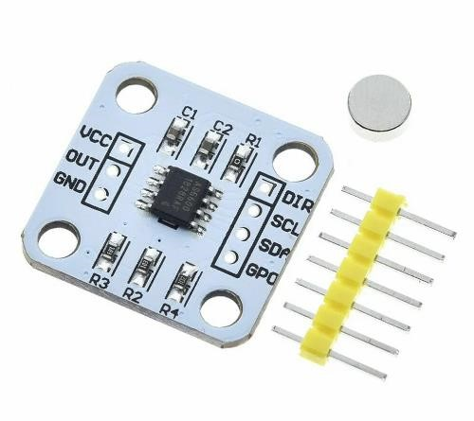

Figure 2.23: AS5600 hall angle sensor

Microcontroller: Component usage requires a microcontroller to be used according to the need of the device protocols. So, Arduino nano R3 is used which provides a wide range of capabilities to be incorporated. The operating Microcontroller is AVR Atmega328p. The operating logic voltage is 5V, which is the most common of the microcontrollers. In addition, the microcontroller provides USB (Universal Serial Bus) to TTL (Transistor to Transistor Logic) chip RS232 which enables real time debugging of the module. This debugging is beneficial in the process of prototyping. Furthermore, the chip has 22 potential digital and 8 analog read pins. Also, the chip has 6 8-bit PWM (Pulse width Modulation) pins and 2 external interrupts. Not to mention, the chip support I2C, SPI and TTL protocol. Compared to the same chip in Arduino Uno, the nano version is much cheaper, smaller and breadboard friendly.

Figure: Arduino Nano R3

HC-05: The module is a wireless trans-receiver that uses Bluetooth 5.0 to send data and receive in radio waves. Bluetooth is widely known for its fast and standard communication. Moreover, the module supports serial data transfer at a very fast speed. However, the module is costlier than most other alternatives of wireless communication. Not to mention, the module supports built in encryption of data.

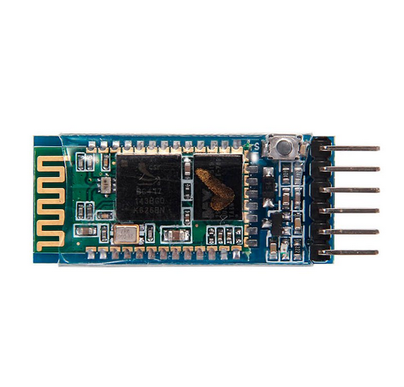

Figure: HC-05

433 MHz wireless transmitter and receiver: The module uses radio waves to send data and receive. The provided transmitter provided data signal in the data input pin sends data wirelessly to be read by a receiver. However, sending data further requires more voltage as the module supports 3-12V as input. Also, the module doesn’t support any kind of built in encryption.

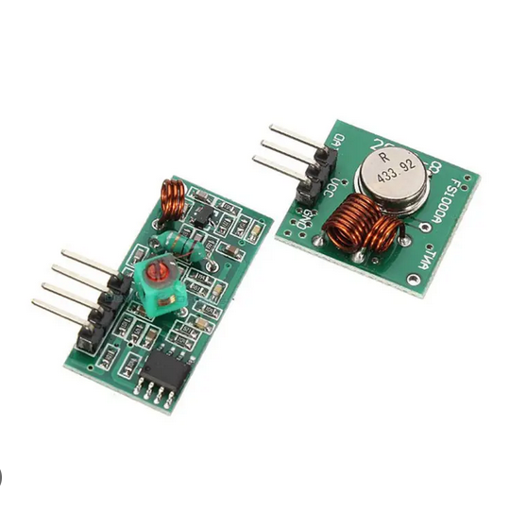

Figure: 433 MHz wireless transmitter and receiver.

Infra-red Communication: The infra-red communication as sounds uses a specific light of same wavelength to be sent and received by another receiver. The communication is wireless. However, the system is prone failure in the cause of obstacles or hindrance. Not to mention, the system doesn’t provide in built data encryption.

Figure: IR sender and receiver.

775 Motor with vacuum attachment: The 775 motors with vacuum attachment allow the electrical power to be utilized by the 775 motor to create a vacuum on the negative pressure side of the attachment. This vacuum after sensing can be used to control the suction of the grabbing head.

#### Figure 2.3: 775 motor rated 12V with vacuum attachment

SMD soldering and desoldering vacuum pen: The vacuum pen is a handheld device that uses a manual negative pressure to grab SMD components by utilizing vacuum. The contact points are high temperature flexible materials which provide enough smooth surface and uniformity to keep the component held on the pen for a accountable long period. Unfortunately, the flexible material is not sold other than this product in retail shops. So, to access the flexible materials, the whole product is to be purchased.

Figure 2.4: Vacuum pen

Flexible vacuum pipe: The flexible vacuum pipe is used to carry the negative pressure from the decompressor to the suction point. The pipe is specially made to endure the vacuum pressure rather than deforming.

#### Figure 2.5: Vacuum flexible pipe (5mm)

HX710B Barometric sensor: The module incorporates MPS20N0040D-D barometric sensor that outputs a value relational with the barometric pressure of the nozzle provided. However, the module only supports serial data interface. The data resolution is 24-bit at data rate of 10-80 samples per second and the sensing range is 0-40 kPa. Although, the absolute vacuum isn’t possible, the desired vacuum sensing capability is viable for the project.

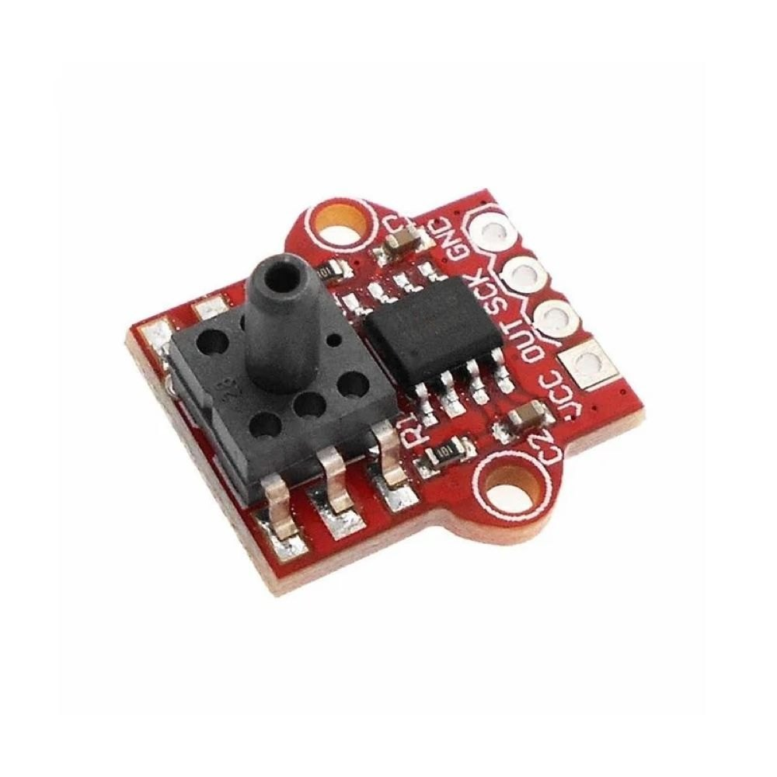

Figure: HX710B IC with vacuum sensor

MAX6675: The module is to be added with a K-type thermocouple to be implemented as a thermometer which will enable the functioning logic circuit to sense the temperature of heated area electrically. The data transfer interface is SPI with 12-bit resolution. Operating voltage supports both 3.3V and 5V. Not to mention, the module is only designed to be implemented with a k type thermocouple.

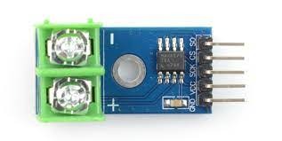

Figure: MAX6675 Module

K-type thermocouple: The most widely used thermocouple type is the K type which is to be used in the project. The sensing range is between 0-600°C.

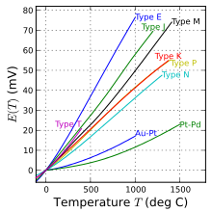

Figure: K-type thermocouple temperature vs voltage curve with other similar thermocouple sensors.

TP4056 : as the project might require wearable device, the choice of battery is li-ion rechargeable battery (Preferably 18650 model) which will need a battery charge and discharge protection circuit. Therefore, the TP4056 is introduced. The type-C model is the most used charging protocol in present. Moreover, the module provides features such as overcharge, over discharge, charging indication at a theoretical wattage of 4.2 watts.

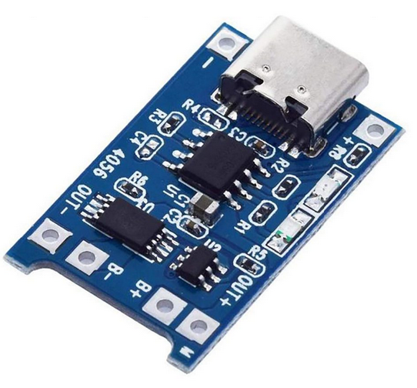

Figure: TP4056 charge and discharge module (Type-C).

LM2596S: The module is to convert 12V/ 24V power supply into 5V power supply. As, buck converters are very efficient in saving and delivering power, this model is chosen rather than linear voltage regulators. The maximum rated power is 25W.

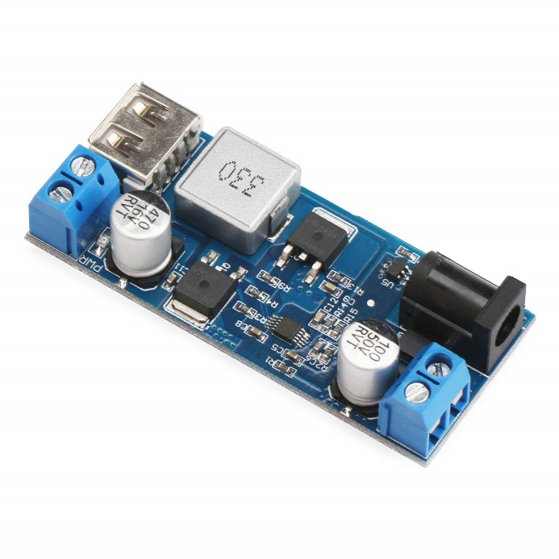

Figure: LM2596S 12V to 5V converter.

Solid state relay: The solid state relay module is to be used to control the passing of ac power through the heated. The module requires driving signal between 3 and 32VDC to enable the AC transmission. However, mechanical relay are also usable but the delayed action, voltage spike and mechanical wear are discouragement for that.

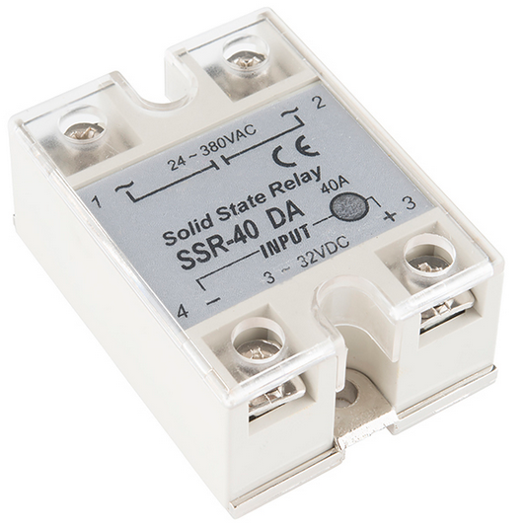

Figure: Solid state relay module.

RPi 3B+: Rpi (Raspberry Pi) 3B+ is a widely used single board computer that can be efficiently utilized to run programs like python, html etc. Also, the module is used for image processing very often.

#### Table 2.7: Specifications of Raspberry Pi 3B+

|  |  |
| --- | --- |
| Category | Details |
| Processor | Broadcom BCM2837B0, Cortex-A53  (ARMv8) 64-bit SoC @ 1.4GHz |
| RAM | 1GB LPDDR2 SDRAM |
| Wireless connectivity | 2.4GHz and 5GHz IEEE 802.11 b/g/n/ac wireless LAN, Bluetooth 4.2, BLE |
| Ethernet | Gigabit Ethernet over USB 2.0  (maximum throughput 300 Mbps) |
| GPOI | Extended 40-pin GPIO header |
| Video interface | Full-size HDMI® |
| USB | 4 USB 2.0 ports |
| Camera connectivity | CSI camera port for connecting a  Raspberry Pi camera |
| Display connectivity | DSI display port for connecting a Raspberry Pi touchscreen display. |
| Audio and composite output | 4-pole stereo output and composite video port |
| ROM | Micro SD port for loading your operating system and storing data |
| Power | 5V/2.5A DC power input |
| POE | Power-over-Ethernet (PoE) support  (requires separate POE HAT) |

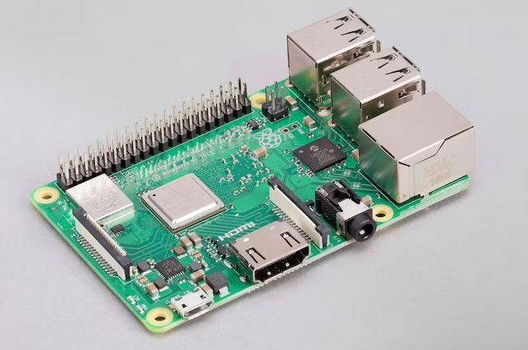

#### Figure 2.28: Raspberry Pi 3B+

Class 10 micro-SD card: A minimum of class 10 micro-SD card is necessary for the RPi3B+ to run the operating system.

Figure 2.34: Class 10 micro-SD card

RPi CNC (Computed Numeric Control): The module is a plug in to use the RPi as a CNC controller. The module incorporates driver chips for the stepper motors in the CNC body.

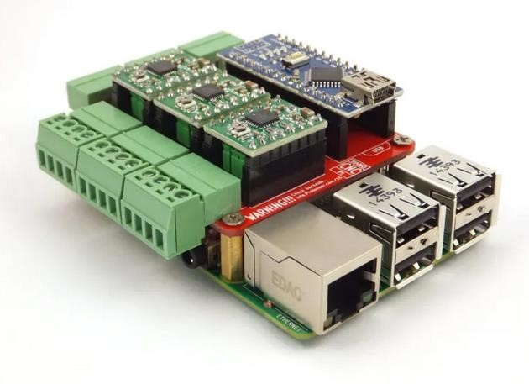

#### Figure 2.29: RPi CNC hat

RPi Camera module: The 5MP camera with 720p video output in 30fps is a viable source of image to be processed by the RPi module to accomplish image processing. The camera module is connected using the CSI (Camera Serial Interface) port of the Raspberry pi module.

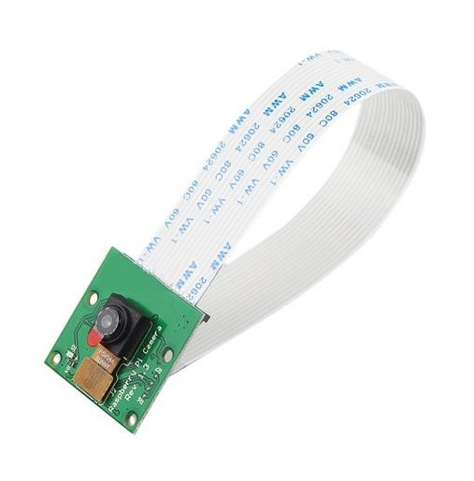

#### Figure 2.30: Raspberry Pi camera module

NEMA 17 stepper motor: The NEMA17 stepper motor is a special type of motor that uses digital power signals to be converted precisely into mechanical signals. The model of this stepper motor is authorized by NEMA (National Electrical Manufacturers Association). The model is the most used in CNC mechanics around the world.

|  |  |
| --- | --- |
| Specifications | Details |
| Phase | 2 |
| Step angle | 1.8° |
| Phase voltage | 12V |
| Current per phase | 1.7A |
| Holding torque | 43 N-cm |

#### Figure 2.32: NEMA 17

TMC2209: The motor driver is chosen to be TMC2209 which is by far the latest updated model of stepper motor drivers supporting micro stepping. The feature micro stepping allows the stepper motors to run smoothly.

Figure 2.35: TMC 2209

3018 pro CNC Structure: The 3018 pro CNC structure is the most used protype CNC structure. As the name suggest, the work bed is 18cm*30cm in size. The structure contains 8mm lead screw with 8mm linear rods with LM8UU bearing. The structure is standing on 6061 aluminum frames with the help of aluminum 2020 and 2040 profile. The structure contains the expansion for NEMA17 motors. The 8mm shaft connect with the stepper motors. Moreover, the design also has expansion for emergency kill switch which is a requirement in industrial application.

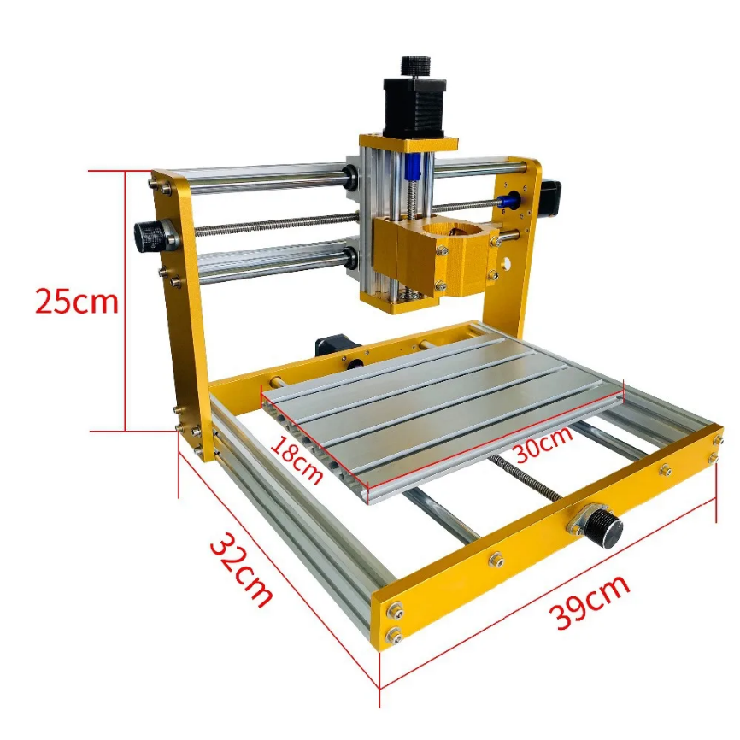

Figure: 3018 pro CNC structure